JUNE 2021

NAMIBIAN UNIVERSITY OF SCIENCE AND TECHNOLOGY

ICG511S PART-TIME GROUP 1 ASSIGNMENT

219130485 BAUDUSSEAU SC BOOYSEN

221033807 TUBUTAME PASCAL

221139133 INACIO F ANDRE

218096887 KENNEY SHEYA

221339915 JOSEPH A SHEYA

Ayesha Beauty Creation system is a web-based salon management application with appointment scheduling functionality. Ayesha Beauty Creation system is a database-oriented project that will manage the transactions in the business. The development of Management System is to act an alternative to the manual operation of process implemented by the business.

Being a client today is inconvenient. You have to remember that you need to make an appointment, then hope you remembered during business hours, and finally scramble to find the phone number and take time out of your busy day to make the call. And never mind finding user reviews of local business and stylists; tracking those down somewhere on the web is a headache that most don’t even attempt. This is the experience of countless business-goers every day, even as we move well into the twenty-first century. Equally surprising, many businesses today are still using paper and pencil systems to schedule appointments and manage customers. These systems are grossly inefficient at sharing and syncing information, and are prone to costly human error. Ayesha Beauty Creation system promises to end the dependence on paper-pencil systems, and put their business in control with an easy-to-use interface. Ayesha Beauty Creation system will be more than just an online website; it will be a customer management tool that will allow users to manage stylists and services, promote sales to customers, and track customer satisfaction and keep all their customer information in a single database.

**Admin**

**Dashboard:** In this section admin can see all detail in brief like total number of customers, Total number of appointments, Rejected Appointment, Accepted Appointment, Total Products and Services, Today’s sales, yesterday’s sale, Last seven days sales and total sales.

**Services:** In this section admin can manage products/services of parlor (add and update).

**Pages:** In this section admin can manage about us and contact us pages.

**Appointment:** In this section admin can view the detail of appointments and have right to reject and select appointment.

**Add Customer:** In this section admin can manage customer(add/update).

**Customer List:** In this section admin can view customer list and assign services and make invoices of services which is taken by customer.

**Reports:** In this section admin can view users’ detail and sales in particular periods

**Invoice:** In this section there is the list of total invoices which is viewed by admin

**Search Appointment:** In this section admin can search appointment with the help of his/her appointment number, name and contact number.

**Search Invoice:** In this section admin can search invoices with the help of his/her invoice number.

Admin can also update his profile, change password and recover password.

**User**

In Ayesha Beauty Creation system user not require to sign in

**Blog page/Homepage:** User can take appointment with beauty parlor on particular date and time.

Product/Services: User views the product/services which is offer by Ayesha Beauty Creation.

**About Us:** User sees the details of Ayesha Beauty Creation.

**Contact Us**: User can contact with Ayesha Beauty Creation.

**Ayesha Beauty Creation system Modules Pseudocode**

1. Admin login

GET LoginID

GET Password

IF (LoginID == EnteredUsername && Password == EnteredPassword) THEN

Login Successful

ELSE

Login Failed.

ENDIF

**LOGIN FLOW CHART**

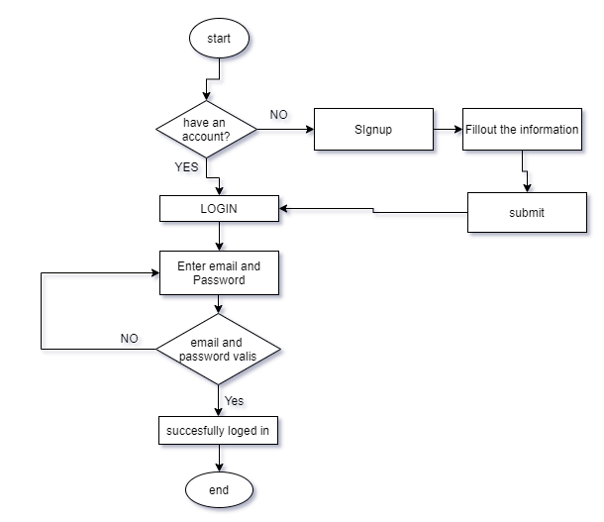

1. **User Module**

CLASS create/update_useraccount__form

Form_Entry()

Get the user's name

Get the user's sex

Get the user's IDno

Get the user's date of birth

Get the email-id user wants

Get the user's password

IF submitted

IF email-id already exists in database THEN

Prompt user for another email-id

Get another email-id from the user

ELSE

IF fields validated THEN

Create the account

Save the record to database

Call Form_Show() method

ELSE

Call Form_Entry() method

END IF

END IF

END IF

Form_Show()

Display the user's email-id

Display the user's password

Display the user's name

Display the user's sex

Display the user's IDno

Display the user's date of birth

Form_Edit()

Get the email-id user wants

Get the user's password

IF email-id and password are valid THEN

Search for the record in reference with the email-id

Call Form_Show() method

Get the user's name

Get the user's sex

Get the user's IDno

Get the user's date of birth

Get the email-id user wants

Get the user's password

UPDATE the record in reference to the email-id

Call Form_Show() method

ELSE

Call Form_Edit method

END IF

**User adding flowchart**

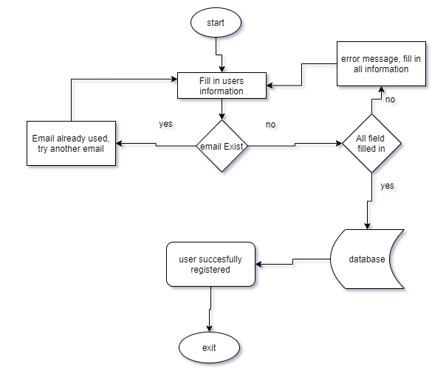

**Updating user flow chart**

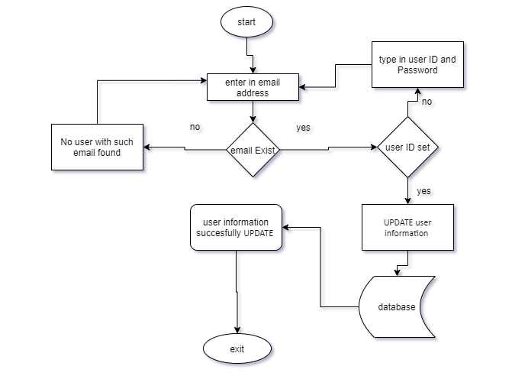

1. **Product/service module**

CLASS creat/update_product__form

Form_Entry ()

Get the user's productid

Get the user's productname

Get the user's description

Get the user's capitalprice

Get the email-id retailprice

Get the user's discount

Get the user's quantity

Get the user's expirydate

IF submitted

IF productid already exists in database THEN

Prompt user for edit product

Get another productid from the user

ELSE

IF fields validated THEN

Create the product

Save the record to database

Call Form_Show() method

ELSE

Call Form_Entry() method

END IF

END IF

END IF

Form_Show()

Display the user's productid

Display the user's productname

Display the user's description

Display the user's capitalprice

Display the user's retailprice

Display the user's discount

Display the user's quantity

Display the user's expirydate

Form_Edit()

Get the productname user wants

Get the productid user wants

IF productname and productid are valid THEN

Search for the record in reference with the productid

Call Form_Show() method

Get the user's productid

Get the user's productname

Get the user's description

Get the user's capitalprice

Get the email-id retailprice

Get the user's discount

Get the user's quantity

Get the user's expirydate

UPDATE the record in reference to the productid

Call Form_Show() method

ELSE

Call Form_Edit method

END IF

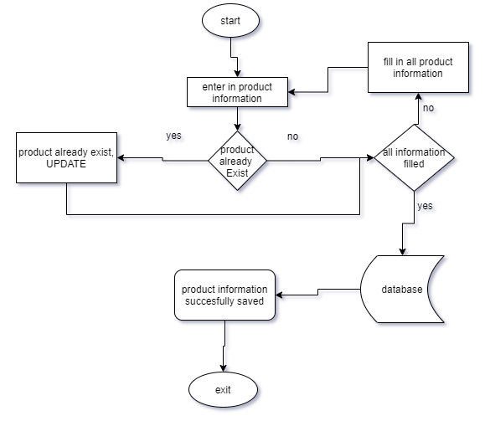

**Customers Module**

ID, Name, Email, MobileNumber, Gender, Details, CreationDate, UpdationDate

CLASS creat/update_customeraccount__form

Form_Entry()

Get the user's name

Get the user's Email

Get the user's MobileNumber

Get the user's Gender

Get the user's CreationDate

Get the user's UpdationDate

IF submitted

IF email-id already exists in database THEN

Prompt user for another update

ELSE

IF fields validated THEN

Create the account

Save the record to database

Call Form_Show() method

ELSE

Call Form_Entry() method

END IF

END IF

END IF

Form_Show()

Display the user's name

Display the user's Email

Display the user's MobileNumber

Display the user's Gender

Display the user's CreationDate

Display the user's UpdationDate

Form_Edit()

Get the email-id customer wants

Get the customer user's password

IF email-id and password are valid THEN

Search for the record in reference with the email-id

Call Form_Show() method

Get the user's name

Get the user's Email

Get the user's MobileNumber

Get the user's Gender

Get the user's CreationDate

Get the user's UpdationDate

UPDATE the record in reference to the email-id

Call Form_Show() method

ELSE

Call Form_Edit method

END IF

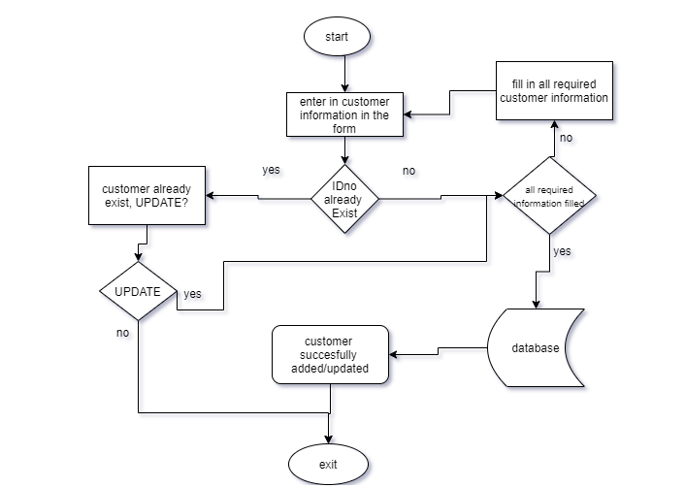

**Blog Module**

Table Fields and Entities: id, PageType, PageTitle, PageDescription, Email, MobliNumber, Timing

CLASS creat/update_blog__form

Form_Entry ()

Get the blog's id

Get the blog's PageType

Get the blog's PageTitle

Get the blog's PageDescription

Get the email-id Email

Get the user's MobliNumber

Get the blog's Timing

IF submitted

IF fields validated THEN

Create the blog

Save the record to database

Call Form_Show() method

ELSE

Call Form_Entry() method

END IF

END IF

END IF

Form_Show()

Display the blog's id

Display the blog's PageType

Display the blog's PageTitle

Display the blog's PageDescription

Display the email-id Email

Display the user's MobliNumber

Display the blog's Timing

Form_Edit()

Get the blottitle user wants

Get the userid user wants

IF blottitle and userid are valid THEN

Search for the record in reference with the productid

Call Form_Show() method

Get the blog's id

Get the blog's PageType

Get the blog's PageTitle

Get the blog's PageDescription

Get the email-id Email

Get the user's MobliNumber

Get the blog's Timing

UPDATE the record in reference to the blog's

Call Form_Show() method

ELSE

Call Form_Edit method

END IF

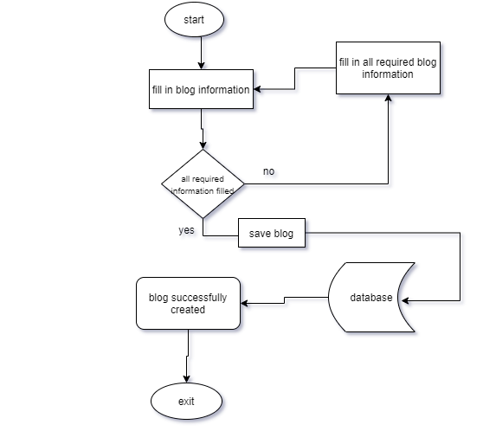

**Appointments Module**

Table Fields and Entities: ID, AptNumber, Name, Email, PhoneNumber, AptDate, AptTime, Services, ApplyDate, Remark, Status, RemarkDate

CLASS creat/update_ Appointments __form

Form_Entry ()

Get the Appointments id

Get the Appointments AptNumber

Get the Appointments Name

Get the Appointments email

Get the Appointments PhoneNumber

Get the Appointments AptDate

Get the Appointments AptTime

Get the Appointments Services

Get the Appointments ApplyDate

Get the Appointments Remark

Get the Appointments Status

Get the Appointments RemarkDate

IF submitted

IF fields validated THEN

Create the Appointments

Save the record to database

Call Form_Show() method

ELSE

Call Form_Entry() method

END IF

END IF

END IF

Form_Show()

Display the Appointments id

Display the Appointments AptNumber

Display the Appointments Name

Display the Appointments email

Display the Appointments PhoneNumber

Display the Appointments AptDate

Display the Appointments AptTime

Display the Appointments Services

Display the Appointments ApplyDate

Display the Appointments Remark

Display the Appointments Status

Display the Appointments RemarkDate

Form_Edit()

Get the service/product customer wants

Get the Appointments customer wants

IF service/product and Appointments are valid THEN

Search for the record in reference with the productid

Call Form_Show() method

Get the Appointments id

Get the Appointments AptNumber

Get the Appointments Name

Get the Appointments email

Get the Appointments PhoneNumber

Get the Appointments AptDate

Get the Appointments AptTime

Get the Appointments Services

Get the Appointments ApplyDate

Get the Appointments Remark

Get the Appointments Status

Get the Appointments RemarkDate

UPDATE the record in reference to the blog's

Call Form_Show() method

ELSE

Call Form_Edit method

END IF